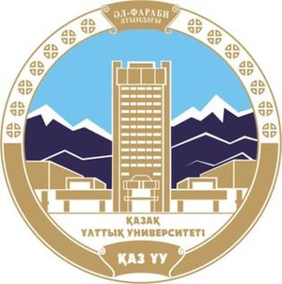

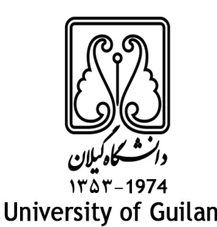
In the Name of God

MEMORANDUM OF UNDERSTANDING (MOU)

Between
University of Guilan, I. R. of Iran,
and
Al-Farabi Kazakh National University, Kazakhstan

Recognizing the importance of academic, research and technological cooperation between universities and research centers for active engagement of academic members and researchers in the domain of science and technology and in order to expand the academic relationships, the University of Guilan (GU) and Al-Farabi Kazakh National University (KAZNU) have agreed as follows:

- To facilitate the exchange of academic members, researchers and experts for conducting research, teaching or exchange of ideas.

- To provide opportunities for professors and researchers to participate in conferences, symposia and international meetings of both universities.

- To provide necessary facilities to exchange professors to spend their sabbatical leaves in each other's universities.

- To collaborate in holding joint scientific, research and technological exhibitions and conducting joint research projects. Furthermore, to facilitate the publication of books and scientific manuscripts.

- To exchange students in the areas of mutual interest consistent with regulations of both countries.

- To exchange information, books, scientific publications, scientific and research documents, students' theses, microfilms and computer software in the educational, research and technological areas.

- To facilitate the visit of academic members, researchers, students of both universities.

- To provide the facilities for participation of students in sport competitions.

- To establish joint programs in postgraduate studies which facilitates student mobility

- To support the establishment of the chair of the languages and literature in the universities of both countries.

- GU voices its readiness to admit the students of KAZNU in short- term courses including Persian language programs. GU is also willing to award scholarship to top students of KAZNU.

- Financing any of the above-mentioned activities shall be subject to the mutual agreements.

- To execute of the any articles of this MOU both parties will set executive program on the basis of the mutual agreement.

- This present agreement shall remain valid for 5 years and may be renewed without notice within six months written notices to the other party.

- This MOU is signed in 15 articles in September, 2019.

University of Guilan Al-Farabi Kazakh National University

Chancellor Rector
Prof. Ahmad Razi Prof. Galymkair Mutanov

